National Endoscopy Database (NED)
Business Message Specification
SendBatchMessage

Version: 1.16.1
Date: 18/01/2018

Contents

1 Contents 2
2 Introduction 4
2.1 Background 4
2.2 Purpose of this document 4
2.3 Scope 5
2.4 Assumptions 6
2.5 References 6
2.6 Abbreviations & Terminology 7
3 Message Content 8
4 Business Message Format 9
4.1 Description 9
4.2 Top Level 9
4.3 SessionType 10
4.4 ProcedureType 11
4.5 PatientType 13
4.6 DrugsType 14
4.7 StaffMembersType 15
4.8 TherapeuticType 16
4.9 IndicationsType 17
4.10 DiagnosesType 17
4.11 AdverseEventsType 18
4.12 Other Types 19
5 Additional Business Validation (ABV) 30
5.1 Hospital site code 30
5.2 Extent 30
5.3 Limited by 30
5.4 Antibiotics given 30
5.5 Pharyngeal Anaesthesia 30
5.6 Polyps detected 30
5.7 Digital Rectal Examination Performed 30
5.8 Magnetic endoscope imager used 30
5.9 Scope Withdrawal time 30
5.10 J manoeuvre performed 30
5.11 Therapeutic type 30
5.12 Biopsy taken from 31
5.13 Indications 31
5.14 Diagnosis 31
5.15 Adverse events 31
5.16 Tattoo 31
5.17 Procedure role 31
5.18 Bowel Preparation 31
6 Appendix A – Visualizing the Schema file 32
7 Appendix B – Schema file 33
8 Document Control 41

Introduction
This document provides information concerning the National Endoscopy Database (NED) interface and describes the scope, purpose and overview of the NED project.

Background
The JAG is introducing a facility to enable Endoscopy System Suppliers to submit, electronically, procedure information on behalf of endoscopists to a national database, NED.
Endoscopy System Suppliers who wish to use the NED Import service must register with the JAG to do so.
Use of the NED Import service will remove the need for endoscopists to manually key in procedure data thus saving time, improve quality and increase coverage of procedures recorded throughout England.

Purpose of this document
This document defines the detailed format and content for the logical business message, which enable the electronic communication of procedure information between the Endoscopy System Supplier and NED. It is aimed, primarily, at technicians and analysts who need a detailed understanding of these messages when involved in implementing an end point connection to the interface (e.g. from a local Endoscopy system).

Scope
This document is one of a number that when taken together describe the NED Import service. The complete documentation set is shown in the following table, with this document highlighted.
Document | Description
Business Message Specification  SendBatchMessage  Version 1.04 | Defines the content of the business message that will pass from the Local Endoscopy System to NED.
Business Message Specification  GetBatchStatusMessage  Version 1.16 | Defines the content of the message received by the Local Endoscopy System when querying the status of a procedure batch in NED.
Interface Specification  Version 1.16 | Defines the operational interface and security requirements for connecting to NED Import service including the transmission of data.
Website specification  Version 1.00 | Defines how to use the NED website to upload data manually and monitor procedure data being imported.

The focus of this document is the physical message format of the business messages used for the business information exchange between the end points (Local Endoscopy System and NED).

Assumptions
The content of this document is based on the following assumptions.
- The procedure data message will always contain at least one procedure – this implies that the Local Endoscopy System supplier will never send empty batches.

References
The table below lists references to other relevant documentation. References to these documents, within the text of this document, are made using the square-bracket notation shown in the “Ref” column of the table.
Ref | Description
[1] | Interface specification document.
[2] | Website specification document.

Abbreviations & Terminology
This section provides definitions of abbreviations and unusual terminology used in this document.
Abbreviations
Abbreviation | Meaning
ES | Endoscopy System Supplier
NED | National Endoscopy Database
JETS | JAG Endoscopy Training System (www.jets.nhs.uk)
JAG | Joint Advisory Group on GI Endoscopy (www.thejag.nhs.uk)
µg | Microgram (mcg)
Mg | Milligrams
ODS | Organisation Data Service (ODS) codes  For example: RGQ for IPSWICH HOSPITAL NHS TRUST.  A complete listing can be found in the blow  (http://www.connectingforhealth.nhs.uk/systemsandservices/data/ods/datafiles/tr.csv/view)
ERS | Endoscopy Reporting System

Terminology
Term | Meaning
XML Schema | A standard for defining the format of XML documents. The standard provides a means by which tools can know the correct format of a document, enabling them to provide generic operations such as validation

Message Content

This section of the document provides detailed descriptions of the business data content that is contained within each business message that can be communicated over the NED Import service interface.
It defines, at a detailed level, the business data that each message communicates and the technical format for the representation of that business data. It does not contain any information related to the creation of a message or the mechanism of its delivery, nor does it define the format of message wrappers or headers. All these are covered in the Interface Control Document [1].
XML documents provide the ability to organise data contained within them hierarchically. This approach is reflected in the data definitions that follow, both to indicate how the data is organised and to allow lengthy definitions to be provided in a digestible manner. The approach taken is to describe data content at higher levels and, within these, make reference to lower level detail that is subsequently expanded. These lower levels of the data structure are referred to within the text as sub-structures. In XML, these are known as complex types.
The data content is described in tabular format and using diagrams to illustrate the XML structures used. Each data item is described by name and by a more lengthy description. A column indicates whether the data item is mandatory or optional and a further column defines the type or format of the data.
Data items within a lower level sub-structure that is referenced from higher levels may be marked as mandatory even though the entire sub-structure is marked as optional at the higher level. Where this occurs, it indicates that the data item is mandatory within the sub-structure if the sub-structure is included.
The Type/Format column either describes the format of the data for the relevant data item (e.g. YYYY for a 4-digit year) or references a description elsewhere. Where this references a lower-level sub-structure that is defined as part of the definition of that message, the name used to make that reference is shown in italic text and refers to the relevant sub-heading within the document. References are also made to sub-structures that are applicable to more than one message (shared complex types) and to definitions that describe a set of valid values to which the item is constrained or other formatting constraints that are too lengthy to fit neatly in the table. These are defined in separate sub-sections of this section of the document after the individual message definitions.
The tables provided for the message includes an additional column labelled ‘ABV’. This column includes a ‘Y’ (for ‘Yes’) to indicate items that have additional business validation (i.e. over and above XML schema validation) upon receipt of the message from NED. The additional business validation is described in section 5 of this specification.
The XML schemas that specify these message formats at a machine-readable technical level are provided at the end of this document.

Business Message Format

Description
This data definition describes the logical groups for this message. It provides the data for a batch of sessions belonging to a hospital/unit, each batch contains one or more procedures.
Note: The complete expanded visual representation of the XML Schema can be found in Appendix A.

Top Level
The following diagram and table describe the data content of this data definition at the top level, with the sub-sections that follow drilling down into further detail.
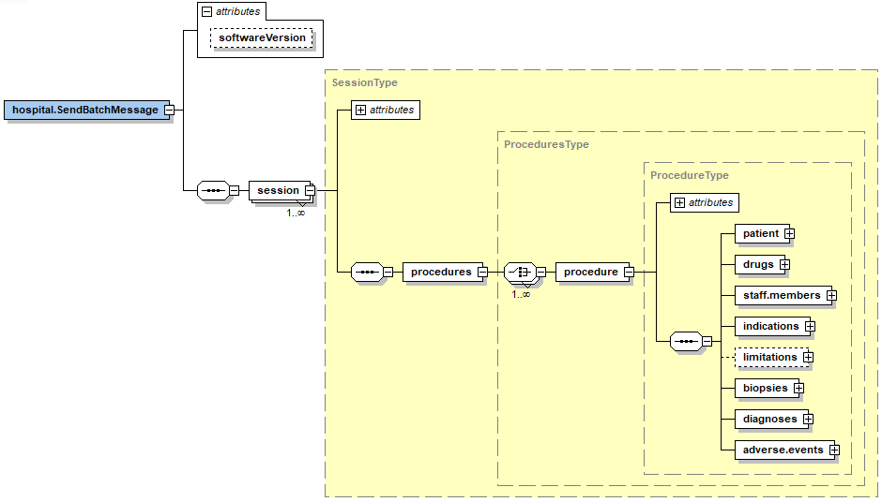
Type | Description
softwareVersion | (Attribute to hospital.sendBatchMessage) Allowing ERS supplier to specify their ERS version String (50 Max).
session | Provides session level information containing one or more procedures.
procedures | Provides a grouping of procedures.
Procedure | Provides procedure information
patient | Provides patient demographics information.
drugs | Provides information on drugs dosages.
staff.members | A list of staff who were present during the procedure.
indications | A list of indications for the procedure.
Limitations | A list of limitations for the procedure.
Biopsies | A list of biopsies for the procedure.
diagnoses | A list of diagnoses for the procedure.
adverse.events | A list of adverse events that may have occurred during the procedure.

SessionType
The Session structure provides various elements of information relating to a unique session.
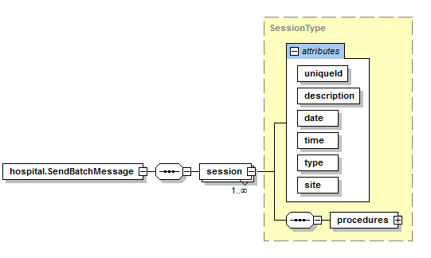
Attributes
Content | Type | Description | ABV | M/O
uniqueId | String (255 Max) | A local unique Identification used to identify the session within the ERS. |  | M
description | string | A local description of the session e.g. local session name. |  | M
date | UKDateType | The date the session was undertaken.  See Other Types sub-section. |  | M
time | TimeEnum | When during the day the session was undertaken.  See Other Types sub-section. |  | M
type | SessionTypeEnum | The type of list this session belongs to.  See Other Types sub-section. |  | M
site | string | Unique hospital site code where the session has taken place (ODS Code) | Y^{5.1} | M

ProcedureType
The procedure structure provides various elements of information relating to a procedure.

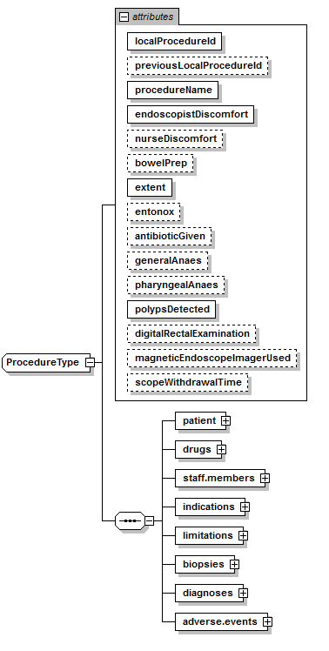

Attributes
Content | Type | Description | ABV | M/O
localProcedureId | String (255 Max) | A local unique Identification number (as used by the ERS) is used in conjunction with the hospital ODS code to identify the individual procedure. This identifier is then used to subsequently update that unique procedure. |  | M
previousLocalProcedureId | String (255 Max) | If the patient has a previous procedure specify what the local unique Identification number for that procedure was.¹ |  | O
procedureName | ProcedureNameEnum | The type of procedure |  | M
endoscopistDiscomfort | DiscomfortEnum | The discomfort score as recorded by the endoscopist performing the procedure.  See Other Types sub-section. |  | M
nurseDiscomfort | DiscomfortEnum | The discomfort score as recorded by the nurse assisting in the procedure.  See Other Types sub-section. |  | O
bowelPrep | BowelPrepEnum | Using a modified version of Aronchick to provide the bowel prep rating. | Y^{5.19} | O
extent | ExtentTypeEnum | The overall extent of the examination | Y^{5.2} | M
entonox | YesNoEnum | Was Entonox given to the patient? |  | O
antibioticGiven | YesNoEnum | Antibiotic given if clinically indicated.  See Other Types sub-section. | Y^{5.4} | O
generalAnaes | YesNoEnum | Was Patient given a general anaesthetic?  See Other Types sub-section. |  | O
pharyngealAnaes | YesNoEnum | Was Patient given a pharyngeal anaesthetic?  See Other Types sub-section. | Y^{5.5} | O
polypsDetected | Integer | Polyps detected (excluding rectal hyperplastic polyps) | Y^{5.6} | M
digitalRectalExamination | YesNoEnum | Was a digital rectal examination performed?  See Other Types sub-section. | Y^{5.7} | O
magneticEndoscopeImagerUsed | YesNoEnum | Was a Magnetic Endoscope used?  See Other Types sub-section. | Y^{5.8} | O
scopeWithdrawalTime | Integer | Time to withdraw scope in minutes. | Y^{5.9} | O

¹ We are currently investigating the option to use pseudonymisation in place of the Previous Local Procedure Id (to provide a cross hospital and cross database relationship).

PatientType
This structure provides information about the patient the procedure was performed on.

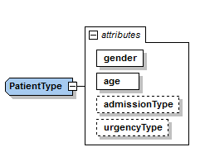
Attributes
Content | Type | Description | ABV | M/O
gender | GenderType | Patients gender  See Other Types sub-section. |  | M
age | Integer | Patients age at procedure |  | M
admissionType | AdmissionTypeEnum | The type of admission for the patient  See Other Types sub-section. |  | O
urgencyType | UrgencyEnum | The type of urgency for the patient.  See Other Types sub-section. |  | O

DrugsType
This structure provides dosages of drugs given to the patient as a result of the procedure.

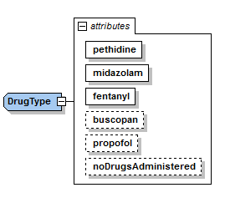
Attributes
Content | Type | Description | ABV | M/O
pethidine | float | Dosage in Milligrams (mg) |  | M
midazolam | float | Dosage in Milligrams (mg) |  | M
fentanyl | float | Dosage in Micrograms (µg) |  | M
buscopan | float | Dosage in Milligrams (mg) |  | O
propofol | float | Dosage in Milligrams (mg) |  | O
noDrugsAdministered | YesNoEnum | Indication that no drugs were administered. |  | O

StaffMembersType
Provides information relating to the staff involved in the procedure and their role during procedure.
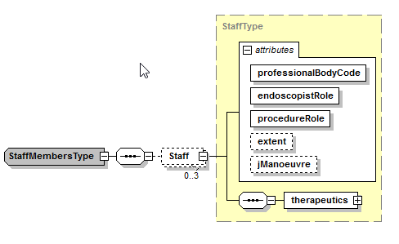
Attributes
Content | Type | Description | ABV | M/O
professionalBodyCode | string | The professional registration number of the staff member, for example GMC/NMC² |  | M
endoscopistRole | EndoscopistRoleTypeEnum | The role of the endoscopist during the procedure e.g. Trainer, Trainee.  See Other Types sub-section. |  | M
procedureRole | ProcedureRoleTypeEnum | The role performed during the procedure e.g. Observing.  See Other Types sub-section. | Y^{5.17} | M
extent | ExtentTypeEnum | The extent which the staff member achieved.  See Other Types sub-section. | Y^{5.2} | O
jManoeuve | YesNoEnum | Was a jManoeuve or Rectal Retroversion carried out by this member of staff.  See Other Types sub-section. | Y^{5.10} | O
therapeutics | TherapeuticType | List of Therapeutic procedures carried out |  | M

² Staff members who do not have a professional body code can obtain a local NED code by logging into NED and going to their “My profile” page.

TherapeuticType
Provides information relating to the Therapeutic procedures performed by a staff member.
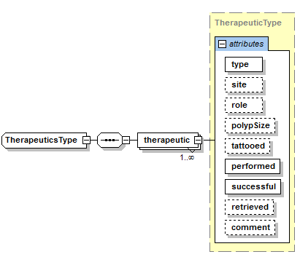
Attributes
Content | Type | Description | ABV | M/O
therapeutic | TherapeuticType | The container for all therapeutic procedures that the staff member was responsible for. |  | M
type | TherapeuticLookupEnum | The type of therapeutic procedure.  See Other Types sub-section. | Y^{5.11} | M
site | BiopsyEnum | The location where the therapeutic procedure was performed.  See Other Types sub-section. | Y^{5.20} | O
role | ProcedureRoleTypeEnum | The role of the endoscopist who carried out the therapeutic procedure.  See Other Types sub-section. | Y^{5.19} | O
polypSize | PolypSizeEnum | The size of polyp (if found)  See Other Types sub-section. |  | O
tattooed | TattooEnum | Was Tattooing performed?  See Other Types sub-section. | Y^{5.16} | O
performed | Integer | Number performed |  | M
successful | Integer | Number of successful |  | M
retrieved | Integer | Number retrieved |  | O
Comment | string | Use this field to define what “Other” is when selected. |  | O

IndicationsType
Provides a list of indications for the procedure.
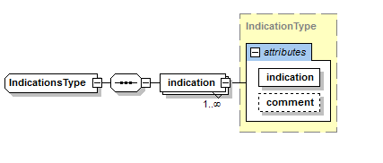
Attributes
Content | Type | Description | ABV | M/O
Indication | IndicationsEnum | The indications for the procedure.  See Other Types sub-section. | Y^{5.13} | M
Comment | string | Use this field to define what “Other” is when selected. |  | O

LimitationsType
Provides a list of limitations for the procedure.
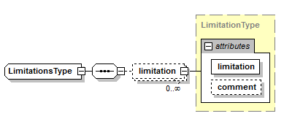
Attributes
Content | Type | Description | ABV | M/O
Limitation | LimitationsEnum | The limitation for the procedure.  See Other Types sub-section. | Y^{5.3} | M
Comment | string | Use this field to define what “Other” is when selected. |  | O

BiopsiesType
Provides a list of biopsies taken for the procedure.

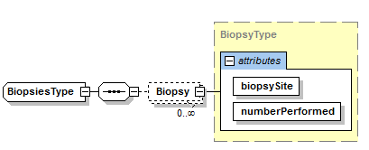
Attributes
Content | Type | Description | ABV | M/O
BiopsySite | BiopsyEnum | The located where the biopsy was taken. See Other Types sub-section. | Y^{5.12} | M
numberPerformed | int | Number of biopsies performed against the selected site location |  | M

DiagnosesType
Provides a list of diagnoses for the procedure and also indicates if tattooing because of a given diagnosis.
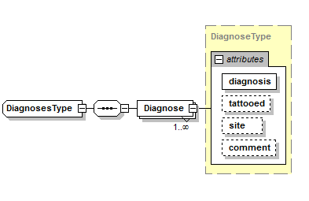
Attributes
Content | Type | Description | ABV | M/O
diagnosis | DiagnosisLookupEnum | A diagnosis for the procedure.  See Other Types sub-section. | Y^{5.14} | M
tattooed | TattooEnum | If tattooing occurred because of the diagnosis e.g. a suspected cancer.  See Other Types sub-section | Y^{5.16} | O
Site | BiopsyEnum | Location of tattoo. | Y^{5.12} | O
Comment | string | Use this field to define what “Other” is when selected. |  | O

AdverseEventsType
Provides a list of adverse events that occurred against the procedure.
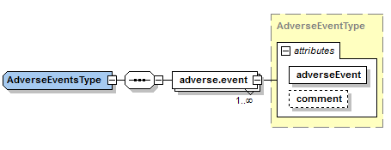

Content | Type | Description | ABV | M/O
adverse.event | AdverseEventEnum | A adverse event  See Other Types sub-section. | Y^{5.15} | M
Comment | string | Use this field to define what “Other” is when selected. |  | O

Other Types

UKDateType
Values of this type represent a date. This is provided in the format DD/MMM/YYYY.
Examples:
01/Jan/2012
22/Jan/2013
TimeEnum
Permitted values for when during the day the list occurred
Valid Values | Meaning
AM | Occurred in the Morning
PM | Occurred during the Afternoon or Evening.

SessionTypeEnum
Permitted values for session type.
Valid Values | Meaning
Dedicated Training List | Trainer present for >= 50% of procedures
Adhoc Training List | Trainer present for <50% of procedures
Service List | No trainer present

ProcedureNameEnum
Permitted values for the type of procedure performed.
Valid Values
OGD
FLEXI
ERCP
COLON

DiscomfortEnum
Permitted values for discomfort score as provided by the Endoscopist /Nurse.
Valid Values | Meaning
Not Specified | --
Comfortable | talking / comfortable throughout
Minimal | 1 or 2 episodes of mild discomfort with no distress
Mild | More than 2 episodes of discomfort without distress
Moderate | Significant discomfort experienced several times with some distress
Severe | Frequent discomfort with significant distress
ExtentTypeEnum
Permitted values for extent reached dependent upon the procedure type.
Valid Values | Colon | Flexi |  | OGD | ERCP
Stomach |  |  |  | Y | Y
Oesophagus |  |  |  | Y | Y
Intubation failed |  |  |  | Y | Y
D2 - 2nd part of duodenum |  |  |  | Y | Y
Duodenal bulb |  |  |  | Y | Y
Anastomosis |  |  |  | Y
Transverse Colon | Y | Y
Terminal ileum | Y | Y
Splenic flexure | Y | Y
Sigmoid colon | Y | Y
Rectum | Y | Y
Pouch | Y | Y
Neo-terminal ileum | Y | Y
Ileo-colon anastomosis | Y | Y
Hepatic flexure | Y | Y
Descending Colon | Y | Y
Caecum | Y | Y
Ascending Colon | Y | Y
Anus | Y | Y
Papilla |  |  |  |  | Y
Pancreatic duct |  |  |  |  | Y
Common bile duct |  |  |  |  | Y
CBD and PD |  |  |  |  | Y
Abandoned | Y | Y | Y |  | Y

LimitationsEnum
Permitted values for limitation if the intended extent was not reached, dependent upon the procedure type.
Valid Values | Colon | Flexi | OGD | ERCP
Other | Y | Y | Y | Y
Not Limited | Y | Y
benign stricture | Y | Y
inadequate bowel prep | Y | Y
malignant stricture | Y | Y
patient discomfort | Y | Y
severe colitis | Y | Y
unresolved loop | Y | Y
clinical intention achieved |  | Y
YesNoEnum
Valid Values
Not Specified
Yes
No

GenderType
Permitted values for the gender of the patient.
Valid Values
Male
Female
Unknown
Indeterminate

AdmissionTypeEnum
Permitted values for the source of the referral.
Valid Values
Not Specified
Inpatient
Outpatient

UrgencyEnum
Permitted values for the urgency of the referral.
Valid Values
Not Specified
Routine
Urgent
Emergency
Surveillance

EndoscopistRoleTypeEnum
Permitted values for the role a staff member performed.
Valid Values
Trainer
Trainee
Independent

ProcedureRoleTypeEnum
Permitted values for a staff role during the procedure
Valid Values | Trainee | Trainer/Independent
Independent (no trainer) | Y | Y
Was observed | Y
Was assisted physically | Y
I observed |  | Y
I assisted physically |  | Y

TherapeuticLookupEnum
Permitted values for therapeutic procedures undertaken by a staff member, dependent upon the procedure type.
Valid Values | Colon | Flexi | OGD | ERCP
None | Y | Y | Y | Y
Other | Y | Y | Y | Y
Argon beam photocoagulation | Y | Y | Y
Balloon dilation | Y | Y | Y | Y
Banding of haemorrhoid | Y | Y
Clip placement | Y | Y | Y
Endoloop placement | Y | Y | Y
Foreign body removal | Y | Y | Y
Injection therapy | Y | Y | Y | Y
Marking / tattooing | Y | Y | Y
Polyp - cold biopsy | Y | Y
Polyp - EMR | Y | Y
Polyp - ESD | Y | Y
Polyp - hot biopsy | Y | Y
Polyp - snare cold | Y | Y
Polyp - snare hot | Y | Y
Stent change | Y | Y | Y | Y
Stent placement | Y | Y | Y
Stent removal | Y | Y | Y | Y
YAG laser | Y | Y | Y
Balloon trawl |  |  |  | Y
Bougie dilation |  |  | Y | Y
Brush cytology |  |  |  | Y
Cannulation |  |  |  | Y
Combined (rendezvous) proc |  |  |  | Y
Diagnostic cholangiogram |  |  |  | Y
Diagnostic pancreatogram |  |  |  | Y
Endoscopic cyst puncture |  |  |  | Y
Haemostasis |  |  |  | Y
Manometry |  |  |  | Y
Nasopancreatic / bilary drain |  |  |  | Y
Sphincterotomy |  |  |  | Y
Stent placement - CBD |  |  |  | Y
Stent placement - pancreas |  |  |  | Y
Stone extraction <10mm |  |  |  | Y
Stone extraction >=10mm |  |  |  | Y
Band ligation |  |  | Y
Botox injection |  |  | Y
EMR |  |  | Y
ESD |  |  | Y
Heater probe |  |  | Y
Hot biopsy |  |  | Y
PEG change |  |  | Y
PEG placement |  |  | Y
PEG removal |  |  | Y
Polypectomy |  |  | Y
Radio frequency ablation |  |  | Y
Variceal sclerotherapy |  |  | Y

BiopsyEnum
Permitted values for where a biopsy was taken dependent upon the procedure type
Valid Values | Colon | Flexi | OGD | ERCP
None | Y | Y | Y | Y
Oesophagus |  |  | Y
Stomach |  |  | Y
Duodenal bulb |  |  | Y
D2 - 2nd part of duodenum |  |  | Y
Terminal ileum | Y
Neo-terminal ileum | Y
Ileo-colon anastomosis | Y
Ascending Colon | Y
Hepatic flexure | Y
Transverse Colon | Y | Y
Splenic flexure | Y | Y
Descending Colon | Y | Y
Sigmoid Colon | Y | Y
Rectum | Y | Y
Anus | Y | Y
Pouch | Y | Y
Caecum | Y | Y

IndicationsEnum
Permitted values for indications, dependent upon the procedure type.
Valid Values | Colon | Flexi | OGD | ERCP
Other | Y | Y | Y | Y
Abdominal pain | Y | Y | Y
Abnormality on CT / barium | Y | Y | Y
Anaemia | Y | Y | Y
Barretts oesophagus |  |  | Y
Diarrhoea |  |  | Y
Dyspepsia |  |  | Y
Dysphagia |  |  | Y
Haematemesis |  |  | Y
Heartburn / reflux |  |  | Y
Melaena | Y | Y | Y
Nausea / vomiting |  |  | Y
Odynophagia |  |  | Y
PEG change |  |  | Y
PEG placement |  |  | Y
PEG removal |  |  | Y
Positive TTG / EMA |  |  | Y
Stent change | Y | Y | Y
Stent placement | Y | Y | Y
Stent removal | Y | Y | Y
Follow up of gastric ulcer |  |  | Y
Varices surveillance / screening |  |  | Y
Weight loss | Y | Y | Y
BCSP | Y
Abdominal mass | Y | Y
Abnormal sigmoidoscopy | Y | Y
Chronic alternating diarrhoea / constipation | Y | Y
Colorectal cancer - follow up | Y | Y
Constipation - acute | Y | Y
Constipation - chronic | Y | Y
Defaecation disorder | Y | Y
Diarrhoea - acute | Y | Y
Diarrhoea - chronic | Y | Y
Diarrhoea - chronic with blood | Y | Y
FHx of colorectal cancer | Y | Y
FOB +'ve | Y | Y
IBD assessment / surveillance | Y | Y
Polyposis syndrome | Y | Y
PR bleeding - altered blood | Y | Y
PR bleeding - anorectal | Y | Y
Previous / known polyps | Y | Y
Tumour assessment | Y | Y
Abnormal liver enzymes |  |  |  | Y
Acute pancreatitis |  |  |  | Y
Ampullary mass |  |  |  | Y
Bile duct injury |  |  |  | Y
Bile duct leak |  |  |  | Y
Cholangitis |  |  |  | Y
Chronic pancreatitis |  |  |  | Y
Gallbladder mass |  |  |  | Y
Gallbladder polyp |  |  |  | Y
Hepatobiliary mass |  |  |  | Y
Jaundice |  |  |  | Y
Pancreatic mass |  |  |  | Y
Pancreatic pseudocyst |  |  |  | Y
Pancreatobiliary pain |  |  |  | Y
Papillary dysfunction |  |  |  | Y
Pre lap choledocholithiasis |  |  |  | Y
Primary sclerosing cholangitis |  |  |  | Y
Purulent cholangitis |  |  |  | Y
Stent dysfunction |  |  |  | Y

DiagnosisLookupEnum
Permitted values for diagnoses, dependent on the procedure type.
Valid Values | Colon | Flexi | OGD | ERCP
Normal | Y | Y | Y | Y
Other | Y | Y | Y | Y
Anal fissure | Y | Y
Angiodysplasia | Y | Y | Y
Colitis - ischemic | Y | Y
Colitis - pseudomembranous | Y | Y
Colitis - unspecified | Y | Y
Colorectal cancer | Y | Y
Crohn's - terminal ileum | Y | Y
Crohn's colitis | Y | Y
Diverticulosis | Y | Y
Fistula | Y | Y
Foreign body | Y | Y
Haemorrhoids | Y | Y
Lipoma | Y | Y
Melanosis | Y | Y
Parasites | Y | Y
Pneumatosis coli | Y | Y
Polyp/s | Y | Y
Polyposis syndrome | Y | Y
Postoperative appearance | Y | Y
Proctitis | Y | Y
Rectal ulcer | Y | Y
Stricture - inflammatory | Y | Y
Stricture - malignant | Y | Y
Stricture - postoperative | Y | Y
Ulcerative colitis | Y | Y
Anastomotic stricture |  |  |  | Y
Biliary fistula/leak |  |  |  | Y
Biliary occlusion |  |  |  | Y
Biliary stent occlusion |  |  |  | Y
Biliary stone(s) |  |  |  | Y
Biliary stricture |  |  |  | Y
Carolis disease |  |  |  | Y
Cholangiocarcinoma |  |  |  | Y
Choledochal cyst |  |  |  | Y
Cystic duct stones |  |  |  | Y
Duodenal diverticulum |  |  | Y | Y
Gallbladder stone(s) |  |  |  | Y
Gallbladder tumor |  |  |  | Y
Hemobilia |  |  |  | Y
IPMT |  |  |  | Y
Mirizzi syndrome |  |  |  | Y
Pancreas annulare |  |  |  | Y
Pancreas divisum |  |  |  | Y
Pancreatic cyst |  |  |  | Y
Pancreatic duct fistula/leak |  |  |  | Y
Pancreatic duct injury |  |  |  | Y
Pancreatic duct stricture |  |  |  | Y
Pancreatic stent occlusion |  |  |  | Y
Pancreatic stone |  |  |  | Y
Pancreatic tumor |  |  |  | Y
Pancreatitis - acute |  |  |  | Y
Pancreatitis - chronic |  |  |  | Y
Papillary stenosis |  |  |  | Y
Papillary tumor |  |  |  | Y
Primary sclerosing cholangitis |  |  |  | Y
Suppurative cholangitis |  |  |  | Y
Achalasia |  |  | Y
Barretts oesophagus |  |  | Y
Dieulafoy lesion |  |  | Y
Duodenal polyp |  |  | Y
Duodenal tumour - benign |  |  | Y
Duodenal tumour - malignant |  |  | Y
Duodenal ulcer |  |  | Y
Duodenitis - erosive |  |  | Y
Duodenitis - non-erosive |  |  | Y
Extrinsic compression |  |  | Y
Gastric diverticulum |  |  | Y
Gastric fistula |  |  | Y
Gastric foreign body |  |  | Y
Gastric polyp(s) |  |  | Y
Gastric postoperative appearance |  |  | Y
Gastric tumour - benign |  |  | Y
Gastric tumour - malignant |  |  | Y
Gastric tumour - submucosal |  |  | Y
Gastric ulcer |  |  | Y
Gastric varices |  |  | Y
Gastritis - erosive |  |  | Y
Gastritis - non-erosive |  |  | Y
Gastropathy-portal hypertensive |  |  | Y
GAVE |  |  | Y
Hiatus hernia |  |  | Y
Mallory-Weiss tear |  |  | Y
Oesophageal candidiasis |  |  | Y
Oesophageal diverticulum |  |  | Y
Oesophageal fistula |  |  | Y
Oesophageal foreign body |  |  | Y
Oesophageal polyp |  |  | Y
Oesophageal stricture - benign |  |  | Y
Oesophageal stricture - malignant |  |  | Y
Oesophageal tumour - benign |  |  | Y
Oesophageal tumour - malignant |  |  | Y
Oesophageal ulcer |  |  | Y
Oesophageal varices |  |  | Y
Oesophagitis - eosinophilic |  |  | Y
Oesophagitis - reflux |  |  | Y
Pharyngeal pouch |  |  | Y
Pyloric stenosis |  |  | Y
Scar |  |  | Y
Schatzki ring |  |  | Y

AdverseEventEnum
Permitted values for adverse events, dependent on the procedure type.
Valid Values | Colon | Flexi | OGD | ERCP
None | Y | Y | Y | Y
Other | Y | Y | Y | Y
Ventilation | Y | Y | Y | Y
Perforation of lumen | Y | Y | Y | Y
Bleeding | Y | Y | Y | Y
O2 desaturation | Y | Y | Y | Y
Flumazenil | Y | Y | Y | Y
Naloxone | Y | Y | Y | Y
Consent signed in room | Y | Y | Y | Y
Withdrawal of consent | Y | Y | Y | Y
Unplanned admission | Y | Y | Y | Y
Unsupervised trainee | Y | Y | Y | Y
Death | Y | Y | Y | Y
Pancreatitis |  |  |  | Y

PolypSizeEnum
Permitted values for Polyp size.
Valid Values
ItemLessThan10mm
Item10to19mm
Item20OrLargermm

BowelPrepEnum
Permitted values for a Modified version of the Aronchick scale.
Valid Values | Description
excellent | >90 % of mucosa seen, mostly liquid stool, minimal suctioning needed for adequate visualization
good | >90 % of mucosa seen, mostly liquid stool, significant suctioning needed for adequate visualization
fair | >90 % of mucosa seen, mixture of liquid and semisolid stool, could be suctioned and / or washed
inadequate | < 90 % of mucosa seen, mixture of semisolid and solid stool that could not be suctioned or washed
Not Specified | Bowel Preparation has not been recorded.

TattooEnum
Permitted values for tattooing.
Valid Values
Yes
No
Previously Tattooed

Additional Business Validation (ABV)

The following additional validation outside of the XSD schema is applied during the upload process.
Where the business validation references another table for “further information” then the ES will need to ensure only those values contained in the table for the given procedure are supplied. Validation will fail if a lookup value belonging to one procedure is used on another where it is not applicable.

Hospital site code
The hospital site code (ODS Code) is validated against the site code being passed when the file is uploaded to the NED Import service. This site code must exist in JETS for the file to be accepted by the interface.

Extent
The extent reached field is procedure specific. See the ExtentTypeEnum table for further information.
An extent is mandatory for a trainee where they have a procedure role of “was assisted physically”.

Limited by
The limited by field is procedure specific. See the LimitationsEnum table for further information.

Antibiotics given
Applies to ERCP only.

Pharyngeal Anaesthesia
Applies to OGD and ERCP only.

Polyps detected
Applies to OGD, Colon and Flexi.

Digital Rectal Examination Performed
Mandatory Yes/No is required for Flexi and Colon procedures.

Magnetic endoscope imager used
Applies to Flexi and Colon only.

Scope Withdrawal time
Applies to Colon only.

J manoeuvre performed
Mandatory Yes/No is required for OGD.
Mandatory Yes/No is required for Colon and Flexi procedures (Rectal retroversion)

Therapeutic type
The Therapeutic type field is procedure specific. See the therapeuticLookupEnum table for further information.

Biopsy taken from
The Biopsy field is procedure specific. See the BiopsyEnum table for further information.

Indications
The indications field is procedure specific. See the IndicationsEnum table for further information.

Diagnosis
The Diagnosis field is procedure specific. See the DiagnosisEnum table for further information.

Adverse events
Adverse events are procedure specific. See the AdverseEventsEnum table for further information.

Tattoo
This field is mandatory if the Therapeutic type polyp size found is greater than 19mm.
Or
A procedure diagnosis of “Colorectal cancer” has been specified.

Procedure role
The procedure role field options are limited to the endoscopist’s Role. See the ProcedureRoleTypeEnum for further information.

Bowel Preparation
Applies to Colon and Flexi only.

Therapeutic Role
This field is optional if the Therapeutic type is none, otherwise it is mandatory.

Site
The site field is procedure specific. See the BiopsyEnum table for further information.
This field is optional if the Therapeutic type is none, otherwise it is mandatory.

Appendix A – Visualizing the Schema file
The following diagram shows a visual representation of the XML schema in its entirety.
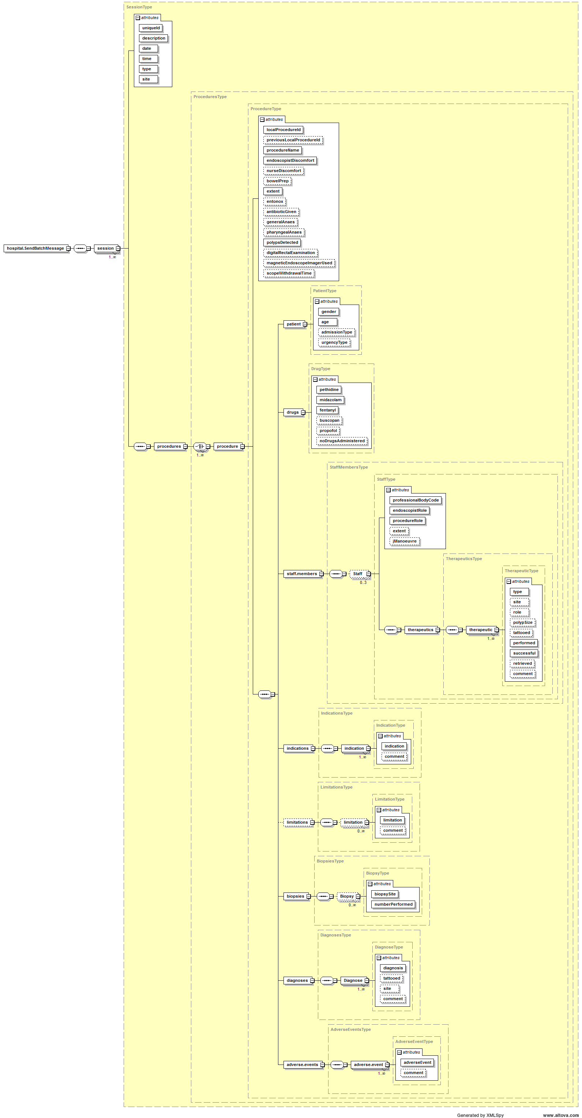

Appendix B – Schema file

<?xml version="1.0" encoding="utf-8"?>
<!-- Version 1.16.1 -->
<xs:schema xmlns="http://weblogik.co.uk/jets/Hospital.SendBatchMessage.xsd" xmlns:mstns="http://weblogik.co.uk/jets/Hospital.SendBatchMessage.xsd" xmlns:xs="http://www.w3.org/2001/XMLSchema" targetNamespace="http://weblogik.co.uk/jets/Hospital.SendBatchMessage.xsd" elementFormDefault="qualified" id="SendBatchMessageFile">
<!-- Root Element -->
<xs:element name="hospital.SendBatchMessage">
<xs:complexType>
<xs:sequence>
<xs:element name="session" type="SessionType" minOccurs="1" maxOccurs="unbounded"/>
</xs:sequence>
<xs:attribute name="softwareVersion" type="xs:string" use="optional"/>
</xs:complexType>
</xs:element>
<!-- Session Element-->
<xs:complexType name="SessionType">
<xs:sequence>
<xs:element name="procedures" type="ProceduresType" minOccurs="1" maxOccurs="1"/>
</xs:sequence>
<xs:attribute name="uniqueId" type="xs:string" use="required"/>
<xs:attribute name="description" type="xs:string" use="required"/>
<xs:attribute name="date" type="UKDateType" use="required"/>
<xs:attribute name="time" type="TimeEnum" use="required"/>
<xs:attribute name="type" type="SessionTypeEnum" use="required"/>
<xs:attribute name="site" type="xs:string" use="required"/>
</xs:complexType>
<xs:complexType name="ProceduresType">
<xs:choice minOccurs="1" maxOccurs="unbounded">
<xs:element name="procedure" type="ProcedureType"/>
</xs:choice>
</xs:complexType>
<!-- Procedure Types -->
<xs:complexType name="ProcedureType">
<xs:sequence>
<xs:element name="patient" type="PatientType" minOccurs="1" maxOccurs="1"/>
<xs:element name="drugs" type="DrugType" minOccurs="1" maxOccurs="1"/>
<xs:element name="staff.members" type="StaffMembersType" minOccurs="1" maxOccurs="1"/>
<xs:element name="indications" type="IndicationsType" minOccurs="1" maxOccurs="1"/>
<xs:element name="limitations" type="LimitationsType" minOccurs="0" maxOccurs="1"/>
<xs:element name="biopsies" type="BiopsiesType" minOccurs="1" maxOccurs="1"/>
<xs:element name="diagnoses" type="DiagnosesType" minOccurs="1" maxOccurs="1"/>
<xs:element name="adverse.events" type="AdverseEventsType" minOccurs="1" maxOccurs="1"/>
</xs:sequence>
<xs:attribute name="localProcedureId" type="xs:string" use="required"/>
<xs:attribute name="previousLocalProcedureId" type="xs:string" use="optional"/>
<xs:attribute name="procedureName" type="ProcedureNameEnum" use="required"/>
<xs:attribute name="endoscopistDiscomfort" type="DiscomfortEnum" use="required"/>
<xs:attribute name="nurseDiscomfort" type="DiscomfortEnum" use="optional"/>
<xs:attribute name="bowelPrep" type="BowelPrepEnum" use="optional"/>
<xs:attribute name="extent" type="ExtentTypeEnum" use="required"/>
<xs:attribute name="entonox" type="YesNoEnum" use="optional"/>
<xs:attribute name="antibioticGiven" type="YesNoEnum" use="optional"/>
<xs:attribute name="generalAnaes" type="YesNoEnum" use="optional"/>
<xs:attribute name="pharyngealAnaes" type="YesNoEnum" use="optional"/>
<xs:attribute name="polypsDetected" type="xs:int" use="required"/>
<xs:attribute name="digitalRectalExamination" type="YesNoEnum" use="optional"/>
<xs:attribute name="magneticEndoscopeImagerUsed" type="YesNoEnum" use="optional"/>
<xs:attribute name="scopeWithdrawalTime" type="xs:int" use="optional"/>
</xs:complexType>
<!-- Staff Types -->
<xs:complexType name="StaffMembersType">
<xs:sequence>
<xs:element name="Staff" type="StaffType" minOccurs="0" maxOccurs="3"/>
</xs:sequence>
</xs:complexType>
<xs:complexType name="StaffType">
<xs:sequence>
<xs:element name="therapeutics" type="TherapeuticsType" minOccurs="1" maxOccurs="1"/>
</xs:sequence>
<xs:attribute name="professionalBodyCode" type="xs:string" use="required"/>
<xs:attribute name="endoscopistRole" type="EndoscopistRoleTypeEnum" use="required"/>
<xs:attribute name="procedureRole" type="ProcedureRoleTypeEnum" use="required"/>
<xs:attribute name="extent" type="ExtentTypeEnum" use="optional"/>
<xs:attribute name="jManoeuvre" type="YesNoEnum" use="optional"/>
</xs:complexType>
<!-- Limitation Element -->
<xs:complexType name="LimitationsType">
<xs:sequence>
<xs:element name="limitation" type="LimitationType" minOccurs="0" maxOccurs="unbounded"/>
</xs:sequence>
</xs:complexType>
<xs:complexType name="LimitationType">
<xs:attribute name="limitation" type="LimitationsEnum" use="required"/>
<xs:attribute name="comment" type="xs:string" use="optional"/>
</xs:complexType>
<!-- Indications Element -->
<xs:complexType name="IndicationsType">
<xs:sequence>
<xs:element name="indication" type="IndicationType" minOccurs="1" maxOccurs="unbounded"/>
</xs:sequence>
</xs:complexType>
<xs:complexType name="IndicationType">
<xs:attribute name="indication" type="IndicationsEnum" use="required"/>
<xs:attribute name="comment" type="xs:string" use="optional"/>
</xs:complexType>
<!-- Diagnoses Element-->
<xs:complexType name="DiagnosesType">
<xs:sequence>
<xs:element name="Diagnose" type="DiagnoseType" minOccurs="1" maxOccurs="unbounded"/>
</xs:sequence>
</xs:complexType>
<xs:complexType name="DiagnoseType">
<xs:attribute name="diagnosis" type="DiagnosisLookupEnum" use="required"/>
<xs:attribute name="tattooed" type="TattooEnum" use="optional"/>
<xs:attribute name="site" type="BiopsyEnum" use="optional"/>
<xs:attribute name="comment" type="xs:string" use="optional"/>
</xs:complexType>
<!-- Biopsies Element -->
<xs:complexType name="BiopsiesType">
<xs:sequence>
<xs:element name="Biopsy" type="BiopsyType" minOccurs="0" maxOccurs="unbounded"/>
</xs:sequence>
</xs:complexType>
<xs:complexType name="BiopsyType">
<xs:attribute name="biopsySite" type="BiopsyEnum" use="required"/>
<xs:attribute name="numberPerformed" type="xs:int" use="required"/>
</xs:complexType>
<!-- Therapeutics Element -->
<xs:complexType name="TherapeuticsType">
<xs:sequence>
<xs:element name="therapeutic" type="TherapeuticType" minOccurs="1" maxOccurs="unbounded"/>
</xs:sequence>
</xs:complexType>
<xs:complexType name="TherapeuticType">
<xs:attribute name="type" type="TherapeuticLookupEnum" use="required"/>
<xs:attribute name="site" type="BiopsyEnum" use="optional"/>
<xs:attribute name="role" type="ProcedureRoleTypeEnum" use="optional"/>
<xs:attribute name="polypSize" type="PolypSizeEnum" use="optional"/>
<xs:attribute name="tattooed" type="TattooEnum" use="optional"/>
<xs:attribute name="performed" type="xs:int" use="required"/>
<xs:attribute name="successful" type="xs:int" use="required"/>
<xs:attribute name="retrieved" type="xs:int" use="optional"/>
<xs:attribute name="comment" type="xs:string" use="optional"/>
</xs:complexType>
<!-- Adverse Events Element -->
<xs:complexType name="AdverseEventsType">
<xs:sequence>
<xs:element name="adverse.event" type="AdverseEventType" minOccurs="1" maxOccurs="unbounded"/>
</xs:sequence>
</xs:complexType>
<xs:complexType name="AdverseEventType">
<xs:attribute name="adverseEvent" type="AdverseEventEnum" use="required"/>
<xs:attribute name="comment" type="xs:string" use="optional"/>
</xs:complexType>
<!-- Patient Element-->
<xs:complexType name="PatientType">
<xs:attribute name="gender" type="GenderType" use="required"/>
<xs:attribute name="age" type="xs:int" use="required"/>
<xs:attribute name="admissionType" type="AdmissionTypeEnum" use="optional"/>
<xs:attribute name="urgencyType" type="UrgencyEnum" use="optional"/>
</xs:complexType>
<!-- Lookup Types -->
<!-- Dose Element-->
<xs:complexType name="DrugType">
<xs:attribute name="pethidine" type="xs:float" use="required"/>
<xs:attribute name="midazolam" type="xs:float" use="required"/>
<xs:attribute name="fentanyl" type="xs:float" use="required"/>
<xs:attribute name="buscopan" type="xs:float" use="optional"/>
<xs:attribute name="propofol" type="xs:float" use="optional"/>
<xs:attribute name="noDrugsAdministered" type="YesNoEnum" use="optional"/>
</xs:complexType>
<xs:simpleType name="SessionTypeEnum">
<xs:restriction base="xs:string">
<xs:enumeration value="Dedicated Training List"/>
<xs:enumeration value="Adhoc Training List"/>
<xs:enumeration value="Service List"/>
</xs:restriction>
</xs:simpleType>
<xs:simpleType name="ExtentTypeEnum">
<xs:restriction base="xs:string">
<xs:enumeration value="Stomach"/>
<xs:enumeration value="Oesophagus"/>
<xs:enumeration value="Intubation failed"/>
<xs:enumeration value="D2 - 2nd part of duodenum"/>
<xs:enumeration value="Duodenal bulb"/>
<xs:enumeration value="Anastomosis"/>
<xs:enumeration value="Transverse Colon"/>
<xs:enumeration value="Terminal ileum"/>
<xs:enumeration value="Splenic flexure"/>
<xs:enumeration value="Sigmoid colon"/>
<xs:enumeration value="Rectum"/>
<xs:enumeration value="Pouch"/>
<xs:enumeration value="Neo-terminal ileum"/>
<xs:enumeration value="Ileo-colon anastomosis"/>
<xs:enumeration value="Hepatic flexure"/>
<xs:enumeration value="Descending Colon"/>
<xs:enumeration value="Caecum"/>
<xs:enumeration value="Ascending Colon"/>
<xs:enumeration value="Anus"/>
<xs:enumeration value="Papilla"/>
<xs:enumeration value="Pancreatic duct"/>
<xs:enumeration value="Common bile duct"/>
<xs:enumeration value="CBD and PD"/>
<xs:enumeration value="Abandoned"/>
</xs:restriction>
</xs:simpleType>
<xs:simpleType name="LimitationsEnum">
<xs:restriction base="xs:string">
<xs:enumeration value="Other"/>
<xs:enumeration value="Not Limited"/>
<xs:enumeration value="benign stricture"/>
<xs:enumeration value="inadequate bowel prep"/>
<xs:enumeration value="malignant stricture"/>
<xs:enumeration value="patient discomfort"/>
<xs:enumeration value="severe colitis"/>
<xs:enumeration value="unresolved loop"/>
<xs:enumeration value="clinical intention achieved"/>
</xs:restriction>
</xs:simpleType>
<xs:simpleType name="AdmissionTypeEnum">
<xs:restriction base="xs:string">
<xs:enumeration value="Not Specified"/>
<xs:enumeration value="Inpatient"/>
<xs:enumeration value="Outpatient"/>
</xs:restriction>
</xs:simpleType>
<xs:simpleType name="UrgencyEnum">
<xs:restriction base="xs:string">
<xs:enumeration value="Not Specified"/>
<xs:enumeration value="Routine"/>
<xs:enumeration value="Urgent"/>
<xs:enumeration value="Emergency"/>
<xs:enumeration value="Surveillance"/>
</xs:restriction>
</xs:simpleType>
<xs:simpleType name="ProcedureRoleTypeEnum">
<xs:restriction base="xs:string">
<xs:enumeration value="Independent (no trainer)"/>
<xs:enumeration value="Was observed"/>
<xs:enumeration value="Was assisted physically"/>
<xs:enumeration value="I observed"/>
<xs:enumeration value="I assisted physically"/>
</xs:restriction>
</xs:simpleType>
<xs:simpleType name="EndoscopistRoleTypeEnum">
<xs:restriction base="xs:string">
<xs:enumeration value="Trainer"/>
<xs:enumeration value="Trainee"/>
<xs:enumeration value="Independent"/>
</xs:restriction>
</xs:simpleType>
<xs:simpleType name="DiscomfortEnum">
<xs:restriction base="xs:string">
<xs:enumeration value="Not Specified"/>
<xs:enumeration value="Comfortable"/>
<xs:enumeration value="Minimal"/>
<xs:enumeration value="Mild"/>
<xs:enumeration value="Moderate"/>
<xs:enumeration value="Severe"/>
</xs:restriction>
</xs:simpleType>
<xs:simpleType name="IndicationsEnum">
<xs:restriction base="xs:string">
<xs:enumeration value="Other"/>
<xs:enumeration value="Abdominal pain"/>
<xs:enumeration value="Abnormality on CT / barium"/>
<xs:enumeration value="Anaemia"/>
<xs:enumeration value="Barretts oesophagus"/>
<xs:enumeration value="Diarrhoea"/>
<xs:enumeration value="Dyspepsia"/>
<xs:enumeration value="Dysphagia"/>
<xs:enumeration value="Haematemesis"/>
<xs:enumeration value="Heartburn / reflux"/>
<xs:enumeration value="Melaena"/>
<xs:enumeration value="Nausea / vomiting"/>
<xs:enumeration value="Odynophagia"/>
<xs:enumeration value="PEG change"/>
<xs:enumeration value="PEG placement"/>
<xs:enumeration value="PEG removal"/>
<xs:enumeration value="Positive TTG / EMA"/>
<xs:enumeration value="Stent change"/>
<xs:enumeration value="Stent placement"/>
<xs:enumeration value="Stent removal"/>
<xs:enumeration value="Follow up of gastric ulcer"/>
<xs:enumeration value="Varices surveillance / screening"/>
<xs:enumeration value="Weight loss"/>
<xs:enumeration value="BCSP"/>
<xs:enumeration value="Abdominal mass"/>
<xs:enumeration value="Abnormal sigmoidoscopy"/>
<xs:enumeration value="Chronic alternating diarrhoea / constipation"/>
<xs:enumeration value="Colorectal cancer - follow up"/>
<xs:enumeration value="Constipation - acute"/>
<xs:enumeration value="Constipation - chronic"/>
<xs:enumeration value="Defaecation disorder"/>
<xs:enumeration value="Diarrhoea - acute"/>
<xs:enumeration value="Diarrhoea - chronic"/>
<xs:enumeration value="Diarrhoea - chronic with blood"/>
<xs:enumeration value="FHx of colorectal cancer"/>
<xs:enumeration value="FOB +'ve"/>
<xs:enumeration value="IBD assessment / surveillance"/>
<xs:enumeration value="Polyposis syndrome"/>
<xs:enumeration value="PR bleeding - altered blood"/>
<xs:enumeration value="PR bleeding - anorectal"/>
<xs:enumeration value="Previous / known polyps"/>
<xs:enumeration value="Tumour assessment"/>
<xs:enumeration value="Abnormal liver enzymes"/>
<xs:enumeration value="Acute pancreatitis"/>
<xs:enumeration value="Ampullary mass"/>
<xs:enumeration value="Bile duct injury"/>
<xs:enumeration value="Bile duct leak"/>
<xs:enumeration value="Cholangitis"/>
<xs:enumeration value="Chronic pancreatitis"/>
<xs:enumeration value="Gallbladder mass"/>
<xs:enumeration value="Gallbladder polyp"/>
<xs:enumeration value="Hepatobiliary mass"/>
<xs:enumeration value="Jaundice"/>
<xs:enumeration value="Pancreatic mass"/>
<xs:enumeration value="Pancreatic pseudocyst"/>
<xs:enumeration value="Pancreatobiliary pain"/>
<xs:enumeration value="Papillary dysfunction"/>
<xs:enumeration value="Pre lap choledocholithiasis"/>
<xs:enumeration value="Primary sclerosing cholangitis"/>
<xs:enumeration value="Purulent cholangitis"/>
<xs:enumeration value="Stent dysfunction"/>
</xs:restriction>
</xs:simpleType>
<xs:simpleType name="DiagnosisLookupEnum">
<xs:restriction base="xs:string">
<xs:enumeration value="Normal"/>
<xs:enumeration value="Other"/>
<xs:enumeration value="Anal fissure"/>
<xs:enumeration value="Angiodysplasia"/>
<xs:enumeration value="Colitis - ischemic"/>
<xs:enumeration value="Colitis - pseudomembranous"/>
<xs:enumeration value="Colitis - unspecified"/>
<xs:enumeration value="Colorectal cancer"/>
<xs:enumeration value="Crohn's - terminal ileum"/>
<xs:enumeration value="Crohn's colitis"/>
<xs:enumeration value="Diverticulosis"/>
<xs:enumeration value="Fistula"/>
<xs:enumeration value="Foreign body"/>
<xs:enumeration value="Haemorrhoids"/>
<xs:enumeration value="Lipoma"/>
<xs:enumeration value="Melanosis"/>
<xs:enumeration value="Parasites"/>
<xs:enumeration value="Pneumatosis coli"/>
<xs:enumeration value="Polyp/s"/>
<xs:enumeration value="Polyposis syndrome"/>
<xs:enumeration value="Postoperative appearance"/>
<xs:enumeration value="Proctitis"/>
<xs:enumeration value="Rectal ulcer"/>
<xs:enumeration value="Stricture - inflammatory"/>
<xs:enumeration value="Stricture - malignant"/>
<xs:enumeration value="Stricture - postoperative"/>
<xs:enumeration value="Ulcerative colitis"/>
<xs:enumeration value="Anastomotic stricture"/>
<xs:enumeration value="Biliary fistula/leak"/>
<xs:enumeration value="Biliary occlusion"/>
<xs:enumeration value="Biliary stent occlusion"/>
<xs:enumeration value="Biliary stone(s)"/>
<xs:enumeration value="Biliary stricture"/>
<xs:enumeration value="Carolis disease"/>
<xs:enumeration value="Cholangiocarcinoma"/>
<xs:enumeration value="Choledochal cyst"/>
<xs:enumeration value="Cystic duct stones"/>
<xs:enumeration value="Duodenal diverticulum"/>
<xs:enumeration value="Gallbladder stone(s)"/>
<xs:enumeration value="Gallbladder tumor"/>
<xs:enumeration value="Hemobilia"/>
<xs:enumeration value="IPMT"/>
<xs:enumeration value="Mirizzi syndrome"/>
<xs:enumeration value="Pancreas annulare"/>
<xs:enumeration value="Pancreas divisum"/>
<xs:enumeration value="Pancreatic cyst"/>
<xs:enumeration value="Pancreatic duct fistula/leak"/>
<xs:enumeration value="Pancreatic duct injury"/>
<xs:enumeration value="Pancreatic duct stricture"/>
<xs:enumeration value="Pancreatic stent occlusion"/>
<xs:enumeration value="Pancreatic stone"/>
<xs:enumeration value="Pancreatic tumor"/>
<xs:enumeration value="Pancreatitis - acute"/>
<xs:enumeration value="Pancreatitis - chronic"/>
<xs:enumeration value="Papillary stenosis"/>
<xs:enumeration value="Papillary tumor"/>
<xs:enumeration value="Primary sclerosing cholangitis"/>
<xs:enumeration value="Suppurative cholangitis"/>
<xs:enumeration value="Achalasia"/>
<xs:enumeration value="Barrett's oesophagus"/>
<xs:enumeration value="Dieulafoy lesion"/>
<xs:enumeration value="Duodenal polyp"/>
<xs:enumeration value="Duodenal tumour - benign"/>
<xs:enumeration value="Duodenal tumour - malignant"/>
<xs:enumeration value="Duodenal ulcer"/>
<xs:enumeration value="Duodenitis - erosive"/>
<xs:enumeration value="Duodenitis - non-erosive"/>
<xs:enumeration value="Extrinsic compression"/>
<xs:enumeration value="Gastric diverticulum"/>
<xs:enumeration value="Gastric fistula"/>
<xs:enumeration value="Gastric foreign body"/>
<xs:enumeration value="Gastric polyp(s)"/>
<xs:enumeration value="Gastric postoperative appearance"/>
<xs:enumeration value="Gastric tumour - benign"/>
<xs:enumeration value="Gastric tumour - malignant"/>
<xs:enumeration value="Gastric tumour - submucosal"/>
<xs:enumeration value="Gastric ulcer"/>
<xs:enumeration value="Gastric varices"/>
<xs:enumeration value="Gastritis - erosive"/>
<xs:enumeration value="Gastritis - non-erosive"/>
<xs:enumeration value="Gastropathy-portal hypertensive"/>
<xs:enumeration value="GAVE"/>
<xs:enumeration value="Hiatus hernia"/>
<xs:enumeration value="Mallory-Weiss tear"/>
<xs:enumeration value="Oesophageal candidiasis"/>
<xs:enumeration value="Oesophageal diverticulum"/>
<xs:enumeration value="Oesophageal fistula"/>
<xs:enumeration value="Oesophageal foreign body"/>
<xs:enumeration value="Oesophageal polyp"/>
<xs:enumeration value="Oesophageal stricture - benign"/>
<xs:enumeration value="Oesophageal stricture - malignant"/>
<xs:enumeration value="Oesophageal tumour - benign"/>
<xs:enumeration value="Oesophageal tumour - malignant"/>
<xs:enumeration value="Oesophageal ulcer"/>
<xs:enumeration value="Oesophageal varices"/>
<xs:enumeration value="Oesophagitis - eosinophilic"/>
<xs:enumeration value="Oesophagitis - reflux"/>
<xs:enumeration value="Pharyngeal pouch"/>
<xs:enumeration value="Pyloric stenosis"/>
<xs:enumeration value="Scar"/>
<xs:enumeration value="Schatzki ring"/>
</xs:restriction>
</xs:simpleType>
<xs:simpleType name="TherapeuticLookupEnum">
<xs:restriction base="xs:string">
<xs:enumeration value="None"/>
<xs:enumeration value="Other"/>
<xs:enumeration value="Argon beam photocoagulation"/>
<xs:enumeration value="Balloon dilation"/>
<xs:enumeration value="Banding of haemorrhoid"/>
<xs:enumeration value="Clip placement"/>
<xs:enumeration value="Endoloop placement"/>
<xs:enumeration value="Foreign body removal"/>
<xs:enumeration value="Injection therapy"/>
<xs:enumeration value="Marking / tattooing"/>
<xs:enumeration value="Polyp - cold biopsy"/>
<xs:enumeration value="Polyp - EMR"/>
<xs:enumeration value="Polyp - ESD"/>
<xs:enumeration value="Polyp - hot biopsy"/>
<xs:enumeration value="Polyp - snare cold"/>
<xs:enumeration value="Polyp - snare hot"/>
<xs:enumeration value="Stent change"/>
<xs:enumeration value="Stent placement"/>
<xs:enumeration value="Stent removal"/>
<xs:enumeration value="YAG laser"/>
<xs:enumeration value="Balloon trawl"/>
<xs:enumeration value="Bougie dilation"/>
<xs:enumeration value="Brush cytology"/>
<xs:enumeration value="Cannulation"/>
<xs:enumeration value="Combined (rendezvous) proc"/>
<xs:enumeration value="Diagnostic cholangiogram"/>
<xs:enumeration value="Diagnostic pancreatogram"/>
<xs:enumeration value="Endoscopic cyst puncture"/>
<xs:enumeration value="Haemostasis"/>
<xs:enumeration value="Manometry"/>
<xs:enumeration value="Nasopancreatic / bilary drain"/>
<xs:enumeration value="Sphincterotomy"/>
<xs:enumeration value="Stent placement - CBD"/>
<xs:enumeration value="Stent placement - pancreas"/>
<xs:enumeration value="Stone extraction &gt;=10mm"/>
<xs:enumeration value="Stone extraction &lt;10mm"/>
<xs:enumeration value="Band ligation"/>
<xs:enumeration value="Botox injection"/>
<xs:enumeration value="EMR"/>
<xs:enumeration value="ESD"/>
<xs:enumeration value="Heater probe"/>
<xs:enumeration value="Hot biopsy"/>
<xs:enumeration value="PEG change"/>
<xs:enumeration value="PEG placement"/>
<xs:enumeration value="PEG removal"/>
<xs:enumeration value="Polypectomy"/>
<xs:enumeration value="Radio frequency ablation"/>
<xs:enumeration value="Variceal sclerotherapy"/>
</xs:restriction>
</xs:simpleType>
<xs:simpleType name="BiopsyEnum">
<xs:restriction base="xs:string">
<xs:enumeration value="None"/>
<xs:enumeration value="Oesophagus"/>
<xs:enumeration value="Stomach"/>
<xs:enumeration value="Duodenal bulb"/>
<xs:enumeration value="D2 - 2nd part of duodenum"/>
<xs:enumeration value="Terminal ileum"/>
<xs:enumeration value="Neo-terminal ileum"/>
<xs:enumeration value="Ileo-colon anastomosis"/>
<xs:enumeration value="Ascending Colon"/>
<xs:enumeration value="Hepatic flexure"/>
<xs:enumeration value="Transverse Colon"/>
<xs:enumeration value="Splenic flexure"/>
<xs:enumeration value="Descending Colon"/>
<xs:enumeration value="Sigmoid Colon"/>
<xs:enumeration value="Rectum"/>
<xs:enumeration value="Anus"/>
<xs:enumeration value="Pouch"/>
<xs:enumeration value="Caecum"/>
</xs:restriction>
</xs:simpleType>
<xs:simpleType name="AdverseEventEnum">
<xs:restriction base="xs:string">
<xs:enumeration value="None"/>
<xs:enumeration value="Other"/>
<xs:enumeration value="Ventilation"/>
<xs:enumeration value="Perforation of lumen"/>
<xs:enumeration value="Bleeding"/>
<xs:enumeration value="O2 desaturation"/>
<xs:enumeration value="Flumazenil"/>
<xs:enumeration value="Naloxone"/>
<xs:enumeration value="Consent signed in room"/>
<xs:enumeration value="Withdrawal of consent"/>
<xs:enumeration value="Unplanned admission"/>
<xs:enumeration value="Unsupervised trainee"/>
<xs:enumeration value="Death"/>
<xs:enumeration value="Pancreatitis"/>
</xs:restriction>
</xs:simpleType>
<!-- Standard Types -->
<xs:simpleType name="BowelPrepEnum">
<xs:restriction base="xs:string">
<xs:enumeration value="Not Specified"/>
<xs:enumeration value="excellent"/>
<xs:enumeration value="good"/>
<xs:enumeration value="fair"/>
<xs:enumeration value="inadequate"/>
</xs:restriction>
</xs:simpleType>
<xs:simpleType name="ProcedureNameEnum">
<xs:restriction base="xs:string">
<xs:enumeration value="OGD"/>
<xs:enumeration value="FLEXI"/>
<xs:enumeration value="ERCP"/>
<xs:enumeration value="COLON"/>
</xs:restriction>
</xs:simpleType>
<xs:simpleType name="GenderType">
<xs:restriction base="xs:string">
<xs:enumeration value="Male"/>
<xs:enumeration value="Female"/>
<xs:enumeration value="Unknown"/>
<xs:enumeration value="Indeterminate"/>
</xs:restriction>
</xs:simpleType>
<xs:simpleType name="YesNoEnum">
<xs:restriction base="xs:string">
<xs:enumeration value="Not Specified"/>
<xs:enumeration value="No"/>
<xs:enumeration value="Yes"/>
</xs:restriction>
</xs:simpleType>
<xs:simpleType name="PolypSizeEnum">
<xs:restriction base="xs:string">
<xs:enumeration value="ItemLessThan10mm"/>
<xs:enumeration value="Item10to19mm"/>
<xs:enumeration value="Item20OrLargermm"/>
</xs:restriction>
</xs:simpleType>
<xs:simpleType name="TattooEnum">
<xs:restriction base="xs:string">
<xs:enumeration value="No"/>
<xs:enumeration value="Yes"/>
<xs:enumeration value="Previously Tattooed"/>
</xs:restriction>
</xs:simpleType>
<xs:simpleType name="TimeEnum">
<xs:restriction base="xs:string">
<xs:enumeration value="AM"/>
<xs:enumeration value="PM"/>
</xs:restriction>
</xs:simpleType>
<xs:simpleType name="UKDateType">
<xs:restriction base="xs:string">
<xs:pattern value="([012]?\d|3[01])/([Jj][Aa][Nn]|[Ff][Ee][bB]|[Mm][Aa][Rr]|[Aa][Pp][Rr]|[Mm][Aa][Yy]|[Jj][Uu][Nn]|[Jj][uU][lL]|[aA][Uu][gG]|[Ss][eE][pP]|[oO][cC][tT]|[Nn][oO][Vv]|[Dd][Ee][Cc])/(19|20)\d\d"/>
</xs:restriction>
</xs:simpleType>
</xs:schema>

Document Control

Date | Version | Change
20/01/2014 | 1.04 | Initial version
05/02/2014 | 1.05 | 1. Entonox is now optional in xml schema.  2. AntibioticGiven is now optional in xml schema, however further business validation check in place to check it can only be specified for a ERCP Procedure.  3. GeneralAnaes is now optional in xml schema.  4. PharyngealAnaes is now optional in xml schema, however further business validation check in place to check it can only be specified for OGD/ERCP Procedures.  5. MagneticEndoscopeImageUsed is now optional in xml schema, however further business validation check in place to check it can only be specified for Colon/Flexi Procedures.  6. DigitalRectalExamination is now optional, however further business validation enforces that a value is specified for Colon/Flexi Procedures.  7. Jmanoeuvre is now optional, however further business validation enforces that a value is specified for OGD/Colon Procedures.  8. ScopeWithdrawalTime is to remain optional in the schema, however it should be noted that further business validation enforces that a value is specified for OGD/Colon procedures.  9. Indications, at least one indication is required per procedure.  10. Diagnosis, at least one indication is required per procedure.  11. Therapeutic, at least one indication is required per procedure.  12. Extent is mandatory for trainees.
24/02/2014 | 1.06 | 1. Biopsy section added.  2. Nurse Discomfort is now optional.  3. Comments added to IndicationType  4. Comments added to TherapeuticType  5. Comments added to AdverseEventType (this is a new type)  6. Biopsy removed from TherapeuticType  7. admission Type is now optional.  8. Urgency is now optional.  9. No Drugs Administered option added to DrugType.  10. Ability to record location and Tattooed for Diagnosis type of colorectal cancer.
10/03/2014 | 1.07 | 1. SessionTypeEnum & SessionType.type have been removed from the schema as the type of session e.g. Dedicated, Training, Service list is now calculated during the import based on the new+existing data and staff roles.  2. The TherapeuticsRoleTypeEnum used on Therapeutic.Role is to be replaced with the standard procedure lookup values as per ProcedureRoleTypeEnum.

09/04/2014 | 1.08 | 1.SessionTypeEnum reinstated and auto calculation removed.  2. Other added to AdverseEventEnum.
22/05/2014 | 1.09 | 1. Remove duplicate YAG Laser from Therapeutics.  2. Max length for session and procedure Ids defined.  3. Scope withdrawal time now only applies to Colonoscopy.  4. Scope withdrawal time redefined as minutes.  5. J manoeuvre (Rectal retroversion) added to Flexi procedures.  6. Allow multiple Limitations to be specified. Also LimitedByEnum has been renamed to LimitationsEnum.  7. Add Caecum to the BiopsyEnum.  8. Staff extent is mandatory for trainees who were physically assisted ( see validation section 5.2 ).
27/05/2014 | 1.10 | 1. Addition of Unknown and Indeterminate to GenderType
04/06/2014 | 1.11 | 1. Allow independent role for trainer in ProcedureRoleTypeEnum.
28/07/2014 | 1.12 | TherapeuticType.role has been made optional when TherapeuticType.type is None.
15/12/2014 | 1.13 | Addition of site to TherapeuticType.
05/02/2015 | 1.14 | 1. DiagnoseType site field now maps to BiopsyEnum rather than ExtentTypeEnum.  2. Removed Colonic biopsy series from BiopsyEnum.
29/03/2016 | 1.5 | Change to web service XML Schema ‘TherapeuticLookupEnum’ lookup values to match NED database using the <> symbols.  - ‘Stone extraction &gt;=10mm’  - ‘Stone extraction &lt;10mm’  Notice the use of xml escape characters, for ‘<’ use ‘&lt;’ and for ‘>’ user ‘&gt;’
24/01/2017 | 1.6 | No Changes to this document.
18/01/2018 | 1.6.1 | Introduction of ‘SoftwareVersion’ string to the top level xml node. This is optional and can be set by ERS suppliers to indicate their ERS software version. Example:  